Kantor Park Bathrooms will OPEN on Tuesday, June 23rd.

- We encourage everyone to utilize their facilities at home whenever possible before coming to the park, but the bathrooms will be open for emergencies.
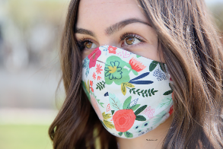
- Everyone using the bathroom needs to have a cloth face covering in place covering nose and mouth. (Patrons under the age of 2 or those with a medical condition prohibiting them from wearing a cloth face covering are exempt, but 6’+ distancing must be maintained.)
- There should not be more than two people in a bathroom at a time, and 6’ of social distancing needs to be maintained.
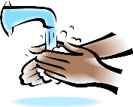
- The CDC recommends frequent hand washing to prevent the spread of COVID-19. Remember to sing “Happy Birthday” to yourself twice to wash the recommended amount of time.
- Footwear is required; no one may enter barefoot.