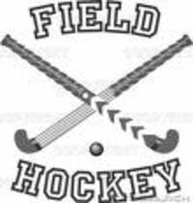
Summer 2020 Field Hockey Clinic
Instructor Vanessa Fowler
For Grades 3rd through 8th (Fall 2020)
Wednesday Evenings: July 1, 8, 15, 22, 29, Aug. 5
(raindate: Aug. 12—add’l raindates will be added if needed)
This is a skills clinic to help participants improve their stick skills and their understanding of the game. Please note, there will not be any goalie training.
All participants must bring their own stick, mouthguard, shin guards, filled water bottle(s).
At the first session of the clinic, each participant will be given their own Field Hockey ball with their name on it to bring to each session. (A limited number of additional Field Hockey balls will be available for purchase should a participant lose their ball.)
Kantor Park Turf Field Gillette, NJ (entire field)
Wednesday Mornings (+ one Monday) Evenings (7/1, 7/8, 7/15, 7/22, 7/29, 8/5, raindate 8/12)
Wednesdays 7/15, 7/22, 7/29, 8/5, 8/12
+ Monday 7/20
Grades ‘3/4: 4pm – 5pm 9am - 10am
Grades 5/6: 5:15pm – 6:15pm 10:15am -11:15am
Grades 7/8: 6:30pm - 7:30pm 11:30am – 12:30am
Each time slot will be capped at 20 participants.
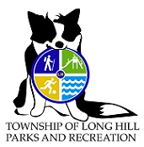
Instructors will wear face coverings/masks. All Participants are strongly encouraged to wear their own face covering/mask as well. All Participants will be required to maintain social distancing. Anyone with a fever will not be allowed to participate until they are cleared by a physician and can return with a doctor’s note. There are no refunds unless the program is canceled.
Register on Community Pass by June 29th, select Summer 2020.
Registration Fee: $50

